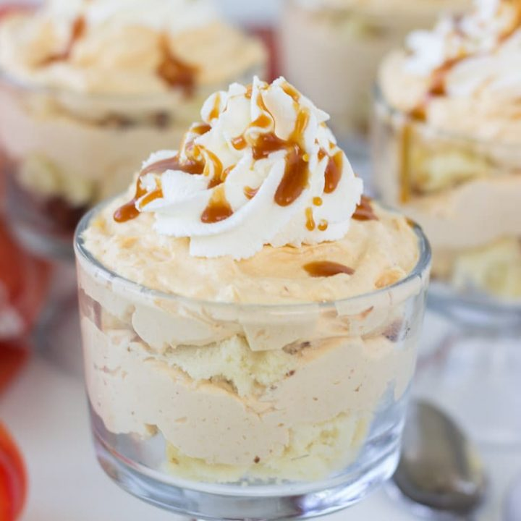

Pumpkin-Cheesecake Trifle

Ingredients
16 ounces PHILADELPHIA Cream Cheese, softened to room temperature
¼ cup granulated sugar
½ cup canned pumpkin puree
½ cup caramel sauce, divided
½ teaspoon cinnamon
1 ½ cup heavy whipping cream, very cold
1 pound cake homemade or use your favorite store bought

Instructions
In a large bowl, combine the cream cheese and sugar. Beat on medium speed until creamy, about 2 minutes. Add the pumpkin, ¼ cup caramel, and spice to the mixture. Continue beating until light and fluffy.
In another bowl, whip the heavy cream until soft peaks form. Beat in 2 to 3 tablespoons caramel sauce. Fold half of the whipped cream into the cream cheese mixture. Save the rest for topping.
Line compote bowl with a layer of the pound cake. Spoon a layer of the pumpkin cream cheese mixture over the cake layer. Repeat the layers ending with the cream cheese mixture.
Top with remaining whipped cream. Drizzle with the rest of the caramel sauce.

